**Lab Assignment 5**

**Scala Programming**

Name: M Jeyapathy

USN: 22BTRAD016

Write a Scala program that creates an abstract class Shape with an abstract method area. Implement subclasses Rectangle and Circle that override the area method

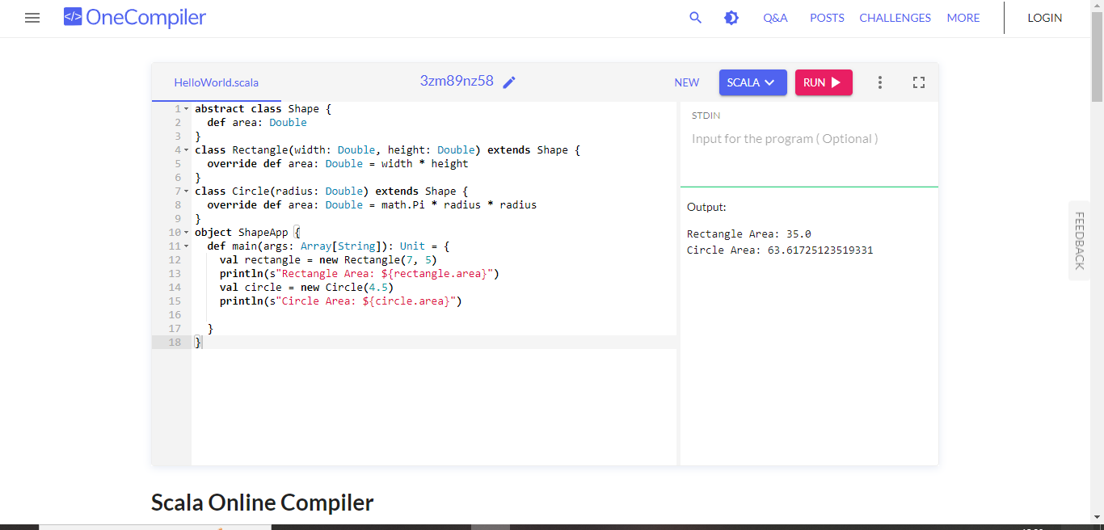

Write a Scala program that creates a class called Person with properties like name, age and country. Implement methods to get and set properties.

